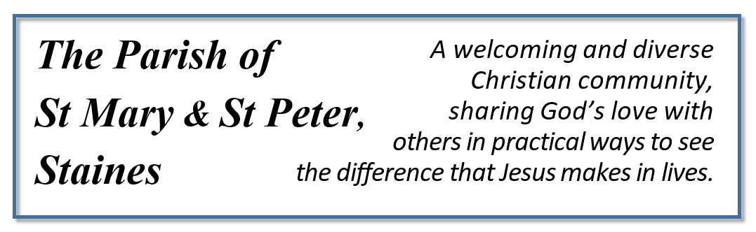Vicar’s Foreword

I am delighted to introduce our new Mission Action Plan for the Parish of St Mary and St Peter, Staines.
We started the process of putting together our Mission Action Plan with a workshop open to all, led by The Rev’d Jonathan Rust, Director of Mission for the Kensington Episcopal Area, in July 2021.
On that Saturday, we had about 30 people for the planning day, and it was a wonderful opportunity to hear from so many of them.

We concluded that we need to focus our energy and resources on five priorities in mission:
-Being an actively welcoming church
-Investing in our outreach to children, young people, and families
-Starting Home Groups and growing in relationships
-Growing in Discipleship and leadership
-Bringing healing and wholeness to the parish and to individual’s lives.

Later in the year, considering the above priorities our PCC produced a Mission Statement for the parish in the following words:
“We are a welcoming and diverse Christian community, sharing God’s love with others in practical ways to see the difference that Jesus makes in lives”.
We are already encouraged by the growth in some of the above areas in recent months and will continue our effort to expand our services to the public.
As we look forward to seeing God’s new work amongst us let us reflect on the prophetic words of Isaiah 43:18-20: “Do not remember the former things or consider the things of old. I am about to do a new thing; now it springs forth, do you not perceive it? I will make a way in the wilderness and rivers in the desert”.
I warmly commend this Mission Action Plan to the Parish, in the hope that it encourages all of us to continue giving our best to God and his kingdom and to see his glory revealed through his church.

Rev. Jonathan Samadi

Current parish activities during the week:
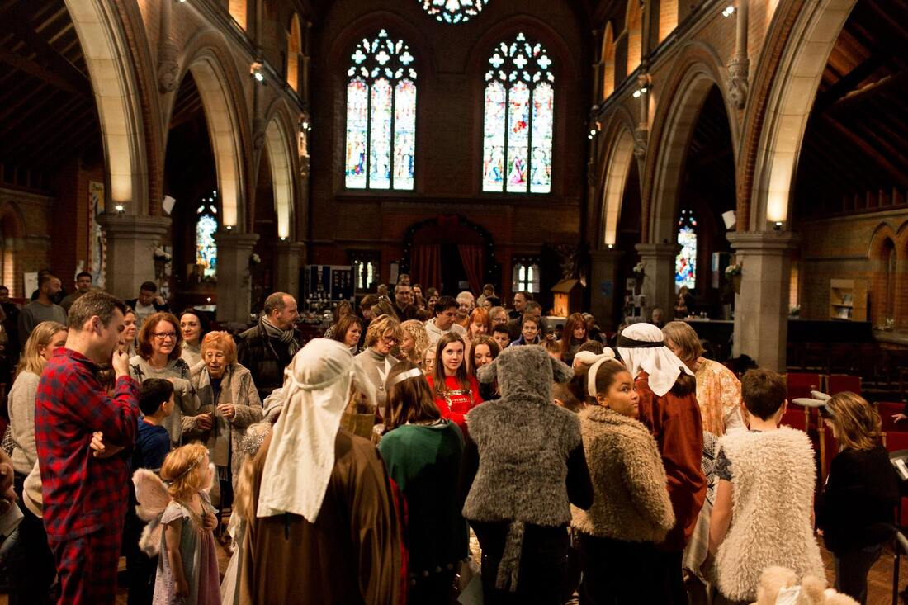
Sundays:
- 9.00am St Mary’s Worship service with Holy Communion except on the third Sunday of each month.
-10.30am St Peter’s Family Service with Holy Communion and Junior Church except on the third Sunday of each month
-10:30am All Age Joint Family Service at St Peter’s, with holy Communion. Once a month on the third Sunday of each month.
Tuesdays:
-DayBreak, 9am-2pm, Day Respite Care. St Peter’s Hall
-Home Group 2pm fortnightly
Wednesdays:
-Carers and Toddlers group,
St Mary’s 10:30am
-Afghan Families’ Group, every Wednesday 2-5pm, St Peter’s Hall
-Home group, fortnightly at 7:30 pm

Thursdays: Midweek Parish Holy Communion, 10:30am at St Peter’s.
Fridays: Parish Prayer Meeting. Once a month on the first Friday of each month at 7:30pm at St Peter’s.
Saturdays:
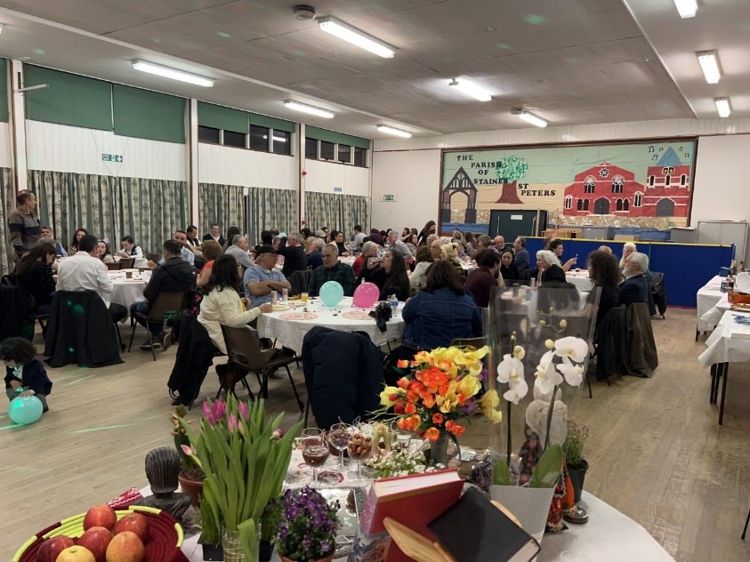
-International Women’s group, 3-5pm at St Peter’s Hall. Once a month on the second Saturday of each month:
-Youth Club, 6-8pm in St Peter’s Hall. Once a month on the second Saturday of each month.

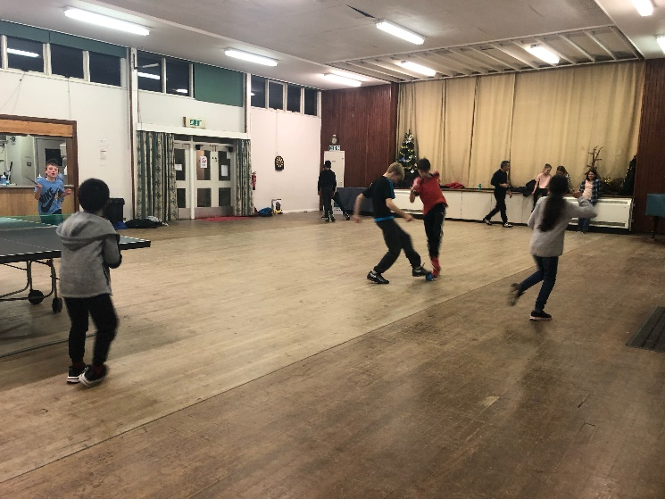
Our Vision
We would like to acknowledge and adapt the Diocesan “2030 Vision” for everyone to encounter the love of God in Christ, with the missional ambition for confident disciples, compassionate communities, and creative growth.
We also recognize the Diocesan priorities in mission to grow younger, to be safer churches and to strive for racial justice. However, for offering effective and fruitful mission in the specific context of our own parish we need to focus first and foremost on our five local priorities:

Being an actively welcoming church
We would love to be a church which is open and welcoming at every opportunity and especially at Sunday services.
We acknowledge the ever-changing nature of our society and the necessity of being relevant, flexible and friendly in our approach to common worship.
We intend for our buildings to be welcoming, well-maintained and to be improved so that they are increasingly suitable for worship and community events.
The reduction of the environmental footprint of the church through the audit and monitoring of our energy, water, paper and ink usage will help us to be an example for the community in looking after God’s creation.
The landscaping of our church gardens and the planting of trees and hedges, increasing biodiversity, and using them as an open space church and prayer garden will offer an opportunity for those who prefer worshipping outdoors. Especially since the pandemic, indoor worshipping can be a cause of anxiety and we have the opportunity to offer our community a beautiful, open-air alternative location for their worship.

Actions needed: Urgent: Improving the AV system in our churches; adding welcome banners and clear signs to the church buildings.
On-going: encouraging the culture of being welcoming and paying attention to each other and especially to new comers before and after the service; involving younger people in the Welcome Team; listening and responding to the wider community.

Investing in our outreach to children, young people, and families
We would love to see our churches thriving now and in the hands of the next generation by including and involving young people in our services and offering an ‘All Age’ format once a month. This will help them to build connections with the wider church and gain a sense of belonging to the church family.
Through the term-time program for Junior Church, we will help children feel welcome, make friends with other children and offer them an opportunity to gain a greater understanding of the Christian faith and ask questions in a safe environment.

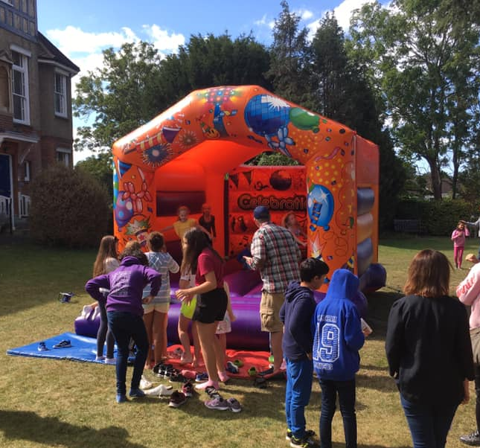
Actions needed: Investing in our Youth Club and Junior Church; employing youth workers; fundraising for youth ministry; building up a team to serve in the long-term; including the young people and teenagers; increasing the frequency of youth club meetings; creating two separate groups for primary and secondary school age children; creating a bond between children and older generation in order for them to have a sense of belonging to the church as God’s family.
Starting Home Groups and growing in relationships
Reflecting on the fruitful example of the early church, we believe that the limited time of Sunday services is not enough for us to grow in better knowledge of each other and to develop a deeper fellowship in Christ.
In order to grow together as God’s church, we need a safe place to share and listen to each other and to ask questions about Christian faith. This can happen in small groups where people journey together and support one another with a bond of friendship, care and encouragement.

Actions needed: Encouraging every member to be part of a home group and to increase the number of home groups in the parish; organizing more social events and opportunities to celebrate together; to combine our two congregations and different generations in order to develop deeper and stronger relationships.

Growing in Discipleship and leadership
Believing in our call to follow Christ, we acknowledge our need to grow in his discipleship and travel with him on our journey of faith. This will involve deepening our knowledge of God’s word and determination to live accordingly.
We would like our parish to be a place of opportunity for ministry, both lay and ordained. Knowing the necessity of raising new leaders, we want to encourage and train those who are called to serve by facilitating their involvement in ministry and providing the necessary training for leadership either in the parish or through the Diocese.

Actions needed: Offering appropriate training for each individual and helping them to discover their calling in ministry; actively looking for people who are called and asking them to join the team.

Bringing healing and wholeness to the parish and to individual’s lives
We acknowledge healing as one of the pillars of Jesus’s ministry according to Luke 4:18-19 and we would like to see his healing power at work in and through his church.
We want our churches to be places for people to encounter the living God and experience his unconditional love through his power of healing. We also want to see his healing restore in us the blessing of and ability for a wholehearted fellowship and unity in Christ.
This can happen through the Biblical teaching in our Sunday services and at our home groups and by offering prayer and ministry to those who are in need of healing in our Sunday services and beyond.

Actions needed: Starting a Prayer Ministry Team to offer prayers after the Sunday services; arranging healing services at least once a term; encouraging our pastoral team’s involvement in visiting the house- bound and offering prayer ministry for healing.

Staff:
Vicar: The Rev’d Jonathan Samadi, vicar@stmaryandstpeterstaines.co.uk
Churchwardens:
St Mary’s: Anna Leach, ecvai@hotmail.com
St Peter’s: Jo Williams, jowilliams52@yahoo.com
Parish Office:
Agi Ryzykowska office@stmaryandstpeterstaines.co.uk
Viv Dover viv@stmaryandstpeterstaines.co.uk
Wendy Ransom, wendyransom1@gmail.com

St Peter’s Hall Manager: Michael Moulton, thesinging.gardener@virgin.net

PCC Secretary: Viv Talkington, vivtalkington@icloud.com
PCC Treasurer: Rebecca Payne, p1nkyrebecca@yahoo.co.uk

Website: www.stmaryandstpeterstaines.co.uk

